nnnnn

Department of software engineering

PROJECT NAME: Maintenance Request System
CS 353 - Database System
PROJECT NAME: Maintenance Request System
SUBMITTED TO:
__________
SUBMITTED BY:
___________
ROLL NO:
___________
DATE OF SUBMISSION:
_____________

Table of Contents
CHAPTER 2: DETAILED DATABASE DESIGN
2.1. Entity
2.2. Data Dictionary
- Request, Staff, Location, Issue Type, Status, Report
2.3. Relationships
2.4. Entity Relationship Diagram (ERD)

2.1 ENTITY:
The Maintenance Request System Database consists of several key entities that represent the main components and activities of the university’s maintenance operations. Each entity stores specific information and interacts with others to ensure smooth tracking and management of maintenance requests, locations, and staff responsibilities.
Sr. No | Entity Name | Description
01 | Request | Stores information about maintenance issues reported by staff or students.
02 | Staff | Holds data about maintenance employees, their specialization, and contact details.
03 | Location | Stores building or room information where maintenance issues occur.
04 | IssueType | Defines the type or category of maintenance problem (e.g., electrical, plumbing).
05 | Status | Tracks the progress or completion state of each request.
06 | Report | Summarizes maintenance activities and staff performance for management reviews.

2.2 DATA DICTIONARY
The data dictionary defines all the entities and their attributes used in the Maintenance Request System Database. It provides detailed information about each table, including attribute names, data types, constraints, and their specific roles within the system.
Each table lists:
- Attribute Name
- Data Type
- Constraints (e.g., Primary Key, Foreign Key, NOT NULL, Unique)
- Description (short and clear explanation)

2.2.1 Request
# | Name | Data Type | Constraint | Description
01 | RequestID | INT | Primary Key, NOT NULL | Unique identifier for each maintenance request.
02 | RequesterName | VARCHAR(100) | NOT NULL | Name of the person reporting the issue.
03 | IssueTypeID | INT | Foreign Key (IssueType) | Links the request to its issue type.
04 | LocationID | INT | Foreign Key (Location) | Identifies where the problem occurred.
05 | AssignedStaffID | INT | Foreign Key (Staff) | Indicates which staff member is assigned the task.
06 | StatusID | INT | Foreign Key (Status) | Specifies current status of the request (e.g., Pending, Completed).
07 | Description | VARCHAR(255) | NULL | Details of the maintenance problem.
08 | ReportDate | DATE | NOT NULL | Date the request was submitted.
09 | CompletionDate | DATE | NULL | Date the maintenance was completed.

2.2.2 Staff
# | Name | Data Type | Constraint | Description
01 | StaffID | INT | Primary Key, NOT NULL | Unique ID for each maintenance staff member.
02 | Name | VARCHAR(100) | NOT NULL | Staff member’s full name.
03 | ContactNumber | VARCHAR(15) | NOT NULL | Phone number of staff member.
04 | Email | VARCHAR(100) | Unique | Official email for communication.
05 | Specialization | VARCHAR(50) | NOT NULL | Area of expertise (e.g., Plumber, Electrician).
06 | ExperienceYears | INT | CHECK (>= 0) | Years of experience in maintenance work.

2.2.3 Location
# | Name | Data Type | Constraint | Description
01 | LocationID | INT | Primary Key, NOT NULL | Unique identifier for each location.
02 | BuildingName | VARCHAR(100) | NOT NULL | Name of the building.
03 | RoomNumber | VARCHAR(10) | NULL | Room or area identifier.
04 | FloorNumber | INT | NULL | Floor number of the location.
05 | Description | VARCHAR(150) | NULL | Additional location details.

2.2.4 IssueType
# | Name | Data Type | Constraint | Description
01 | IssueTypeID | INT | Primary Key, NOT NULL | Unique ID for each issue type.
02 | TypeName | VARCHAR(50) | NOT NULL | Type of issue (e.g., Plumbing, Electrical).
03 | Description | VARCHAR(150) | NULL | Brief details about the issue type.

2.2.5 Status
# | Name | Data Type | Constraint | Description
01 | StatusID | INT | Primary Key, NOT NULL | Unique status identifier.
02 | StatusName | VARCHAR(20) | NOT NULL | Status (e.g., Pending, In Progress, Completed).
03 | Description | VARCHAR(150) | NULL | Explanation of the status condition.

2.2.6 Report
# | Name | Data Type | Constraint | Description
01 | ReportID | INT | Primary Key, NOT NULL | Unique report identifier.
02 | StaffID | INT | Foreign Key (Staff) | Links report to specific staff member.
03 | GeneratedDate | DATE | NOT NULL | Date report was generated.
04 | TotalRequests | INT | CHECK (>= 0) | Total requests handled in the report period.
05 | CompletedRequests | INT | CHECK (>= 0) | Number of completed requests.
06 | PendingRequests | INT | CHECK (>= 0) | Number of pending requests.

2.3 RELATIONSHIPS
The following table defines the relationships between the main entities in the Maintenance Request System Database. Each relationship specifies how entities are connected, the business rules governing their interaction, and the cardinality.
Sr. No | Participating Entities | Relation | Business Rule
01 | Staff, Request | Staff handles Request | A staff member can handle many requests, but each request is assigned to only one staff member (1–M).
02 | Request, Location | Request occurs at Location | A location can have many requests, but each request belongs to one location (1–M).
03 | Request, IssueType | Request has IssueType | An issue type can be used for many requests, but each request has only one issue type (1–M).
04 | Request, Status | Request has Status | A status can apply to many requests, but each request has only one status (1–M).
05 | Staff, Report | Staff included in Report | A staff member can have many reports, but each report is linked to one staff (1–M).
06 | Request, Report | Request summarized in Report | Multiple requests can appear in a single report (1–M).

2.4 ENTITY RELATIONSHIP DIAGRAM
The Entity-Relationship Diagram (ERD) for the Maintenance Request System visually represents how entities interact within the database. It defines how maintenance requests, staff, issue types, and locations are interlinked and ensures referential integrity between all related tables.
Tool Used for ERD Creation
The ERD for this project was created using MySQL Workbench, a professional database design and modeling tool. It automatically generates ER diagrams from SQL code through Reverse Engineering and displays:
- All entities and their attributes
- Primary and foreign key relationships
- Cardinalities (1–1, 1–M, M–M)
- Constraints and referential integrity rules
Assumptions Made
- Each request must have one and only one assigned staff member.
- Each request occurs at a valid location recorded in the database.
- Each issue type is pre-defined and can be used in multiple requests.
- Every request must have a status (Pending, In Progress, Completed).
- Reports summarize requests handled by specific staff members over a defined period.
- Completion dates must always be greater than the report date (CHECK constraint applied).

ER Diagram:
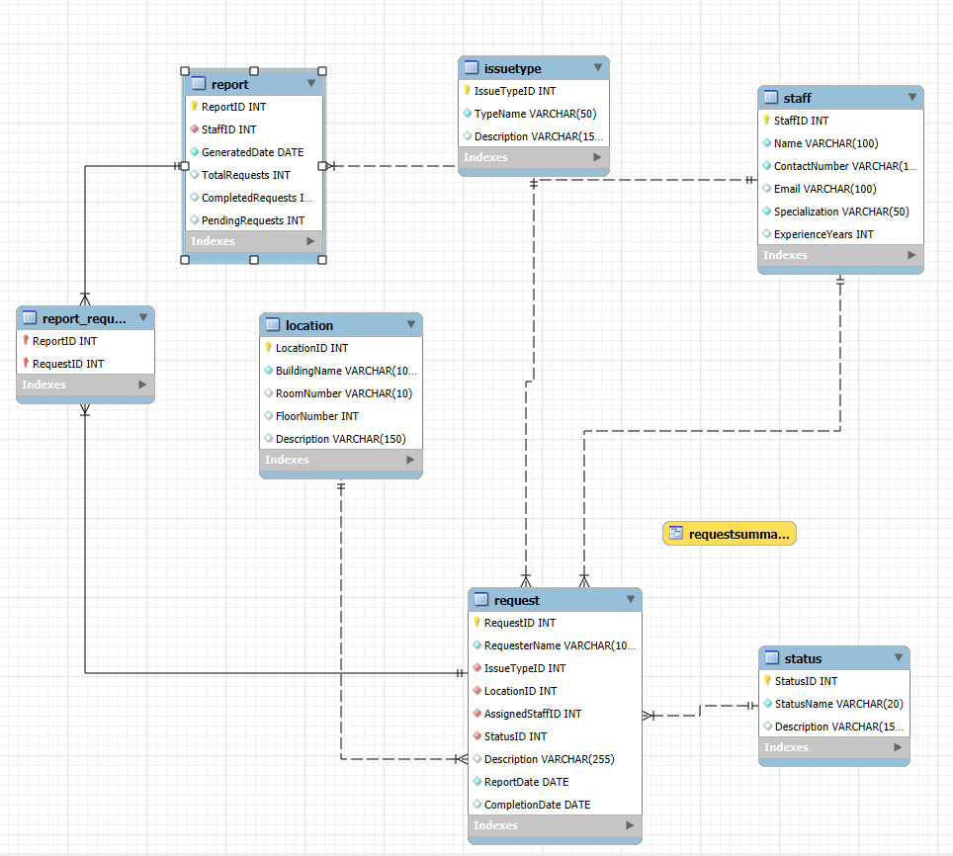

References
- ResearchGate – Practical Database Design for Industrial Maintenance System. https://www.researchgate.net/publication/228857099_Practical_database_design_for_industrial_maintenance_system
- Lucidchart ERD Guide: https://www.lucidchart.com/pages/er-diagrams/
- ChatGPT (GPT-5, OpenAI) – Used for structuring database documentation and entity definition.
- Oracle, MySQL Workbench Documentation – https://dev.mysql.com/doc/workbench/en/

